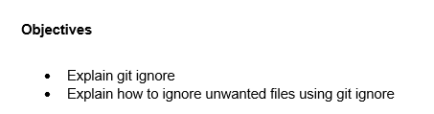

* The .gitignore file in Git specifies intentionally untracked files that Git should ignore. It helps prevent unnecessary files, such as temporary build artifacts or system-specific configurations, from being included in version control. This improves project cleanliness and avoids exposing sensitive or irrelevant data. Patterns defined in .gitignore inform Git which files or directories to exclude. It is a crucial tool for maintaining an organized and efficient repository.
* To ignore unwanted files in a Git project, create a .gitignore file in the root directory. Inside this file, specify file names, directory names, or wildcard patterns that match the files to be excluded. For example, writing *.log ignores all log files. Once specified, Git will not track those files in future commits. This approach ensures that only relevant and necessary files are versioned.

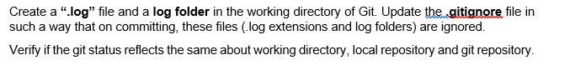**Solution**

